PF LAB 6 SUBMISSION (LOOPS)

ANSWER 1:

#include <stdio.h>

int main(){

int num,sum=0;

do {

printf("Please enter your number: ");

scanf("%d",&num);

sum=sum+num;

} while (num!=0);

printf("Your final sum = %d",sum);

printf("\nDo while loop is the best loop for this code as it ensures that the code will run at least once no matter what the input");

}

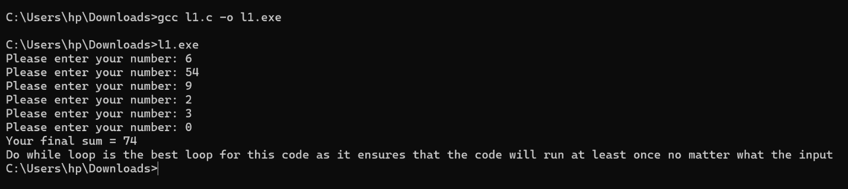

ANSWER 2+3:

#include <stdio.h>

int main(){

int i,number,ans=1;

printf("Enter your number: ");

scanf("%d",&number);

(number<10)?printf("%d is a single digit number\n",number):printf("%d is a multiple digit number\n",number);

if(number<=1) printf("%d is nor prime nor composite",number);

else {

for(i=2;i<number;i++)

{

if(number%i==0)

ans=0;

}

if (ans) printf("%d is a prime number",number);

else printf("%d is a composite number",number);

return 0;

}

}

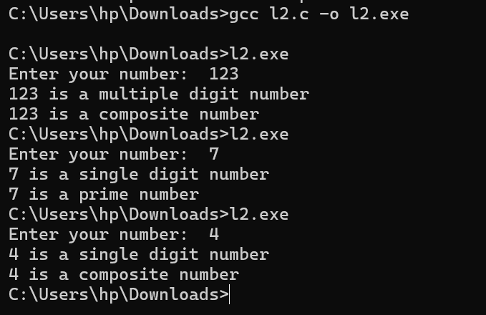

ANSWER 4:

#include <stdio.h>

int main(){

int n1=1,n2=2,sum,terms,a;

sum=n1+n2;

printf("Enter the number of terms you want to print: ");

scanf("%d",&terms);

printf("%d, %d, ",n1,n2);

for (a=3;a<=terms;++a)

{

n1 = n2;

n2 = sum;

sum = n1 + n2;

printf("%d, ",sum);

}

return 0;

}

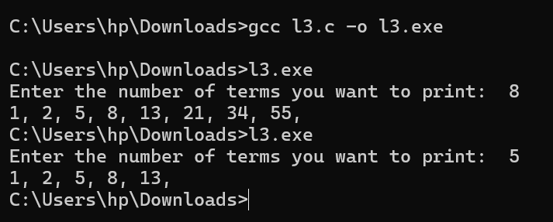

ANSWER 5:

#include <stdio.h>

int main(){

int n1=1,n2=2,mul,terms,a;

mul=n1\*n2;

printf("Enter the number of terms you want to print, upto 9: ");

scanf("%d",&terms);

printf("%d, %d, %d, ",n1,n2,n2);

for (a=3;a<terms;++a)

{

n1 = n2;

n2 = mul;

mul = n1 \* n2;

printf("%d, ",mul);

}

return 0;

}

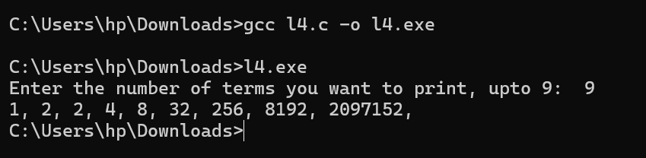

ANSWER 6:

#include <stdio.h>

int main(){

int n1=1,n2=2,mul,terms,a;

mul=n1\*n2;

printf("Enter the number of terms you want to print, upto 9: ");

scanf("%d",&terms);

printf("%d, %d, %d, ",n1,n2,n2);

for (a=3;a<terms;++a)

{

n1 = n2;

n2 = mul;

mul = n1 \* n2;

printf("%d, ",mul);

}

return 0;

}

